ROCHDALE BOROUGH COUNCIL
REDUCTION IN PUPIL ADMISSION NUMBER FOR
STANSFIELD HALL CHRUCH OF ENGLAND / METHODIST CHURCH PRIMARY SCHOOL

Notice is given in accordance with the school Admissions Code that Rochdale Borough Council, Children’s Services, Number One Riverside, Smith Street, Rochdale, OL16 1XU, intends to reduce the admissions intake to Stansfield Hall Church of England / Methodist Church Primary School.

- The name and contact address of the local authority or governing body publishing the
Proposals:
Local Authority: Rochdale Borough Council
Address: School Organisation and Development Team, Early Help & Schools, Rochdale Borough Council, Number One Riverside, Smith Street, Rochdale, OL16 1XU

Date of Publication of Proposals for Consultation: 20th December 2023.

- The name, address and category of the school that is proposed to be altered:
Address: Stansfield Hall Church of England / Methodist Church Primary School, Barnes Meadow, Todmorden Road, Summit, Littleborough, OL15 9PR

Category of school: Voluntary Controlled CE Primary School

- The date in which the proposed changes will take effect in terms of both the buildings and additional place provisions:
1st September 2025.

- The place to which representations can be made, and by when:
Any person can make representations on the proposal by using the following link to the council consultation website at: https://consultations.rochdale.gov.uk/research*** or by sending them by 31st January 2024 to: Fay Davies, by e-mail at fay.davies@rochdale.gov.uk , Gemma Coggin, by e-mail at gemma.coggin@rochdale.gov.uk or in writing to this address: School Admissions, School Organisation & Development Team, Early Help and Schools, Rochdale Borough Council, Number One Riverside, Smith Street, Rochdale, OL16 1XU.

- What is proposed?
The proposal is to permanently reduce Pupil Admission Number at Stansfield Hall Church of England / Methodist Church Primary School, Littleborough from 20 places to 15 places with effect from 1st September 2025.

- School capacity and places- current pupil numbers and admissions- (distinguishing between compulsory and non-compulsory school age pupils), age range, sex, and special educational needs (distinguishing between boarding and day pupils) for whom provision is currently made:
Stansfield Hall is a mainstream Primary school and has 118 pupils on roll from Reception to Year 6 based on the May 2023 school census. The current age range of the children is 4-11 and does not include a nursery.
ROCHDALE  MAY 2023  CENSUS | Places 2022 | Rec NOR | Places 2021 | Year 1 NOR | Places 2020 | Year 2 NOR | Places 2019 | Year 3 NOR | Places 2018 | Year 4 NOR | Places 2017 | Year 5 NOR | Places 2016 | Year 6 NOR | Total NOR
Stansfield Hall CE VC | 20 | 11 | 20 | 11 | 20 | 16 | 20 | 17 | 20 | 18 | 20 | 20 | 30 | 25 | 118

The local authority has a statutory duty to deliver sufficient places for children living in the borough.

- Why do we want to make the change(s)?
Reasons for the reduction of places
7.1 Rochdale Borough Council has a duty to provide sufficient places for children living in the borough. This includes children who move into the borough after the normal start in Reception class and in higher year groups; termed in-year applications. The council has a duty of care to manage school places effectively and schools have a duty to adequately staff their schools.
7.2 The local authority has a duty of care to children in schools to make sure too many empty places are removed in order that the school is adequately financed through its per-pupil funding allocation, and that education is not compromised because of limited finance.
7.3 The applications to schools in North Pennines have dropped significantly since 2021, and an underlying birth increase for 2023 intake did not lead to an increase in uptake of places. The rebuilding of Littleborough Primary and the delay in the new Secondary school is believed to have had an impact.
7.4 Since 2021 birth rates locally have dropped from 248 and will continue to drop until the 2026 intake which has a birth rate of 181. This is a reduction locally of 67 births. Despite new housing developments in the area birth rates continue to fall. Analysis of children from the new housing shows 30% are pre-school and 65% are either higher key stage 2 or Secondary pupils.
7.5 Too much spare capacity is currently available in the forecasted time line across North Pennines.

Quality of Provision

7.6 The current OfSTED report for Stansfield Hall Church of England / Methodist Church Primary School was published in January 2023. The school was judged as ‘Requires Improvement’ for Overall Effectiveness, ‘Inadequate’ for Early Years Provision but ‘Good’ in Behaviour and Attitudes and Personal Development.

7.7 The advantages to the school and the children will be:
- More stability in number of pupils
- The school can staff the classrooms to the correct ratios

7.8 The Governing Body of Stansfield Hall Church of England / Methodist Church Primary School is committed to upholding the standards and ethos of the School. Through the Leadership and Management Team and alongside the Governing Body, the school aspires to provide an 'Outstanding' education to all of the children in its community.

- The need for a reduction in places - a statement and supporting evidence about the need for reducing school places in the area including whether there is sufficient capacity to accommodate additional pupils in the current schools:
8.1 Pupil projections for Rochdale Borough, Township and planning area were published and reported to Cabinet on the 22nd November 2022. Documents were shared with schools on the local authority internal bulletin platform. The consultation information can be found in the link below:

https://consultations.rochdale.gov.uk/research/school-admissions-policy-2024-25

8.2 The need for Primary School Places 2024-2027 Report highlights that the need for a reduction in primary school places going forward within the Pennines planning area remains, key factors being:
- Reduction in local birth rates which follow national trends;
- Reduction in take up of in-year places locally;
- Assessment of new housing developments has been considered.

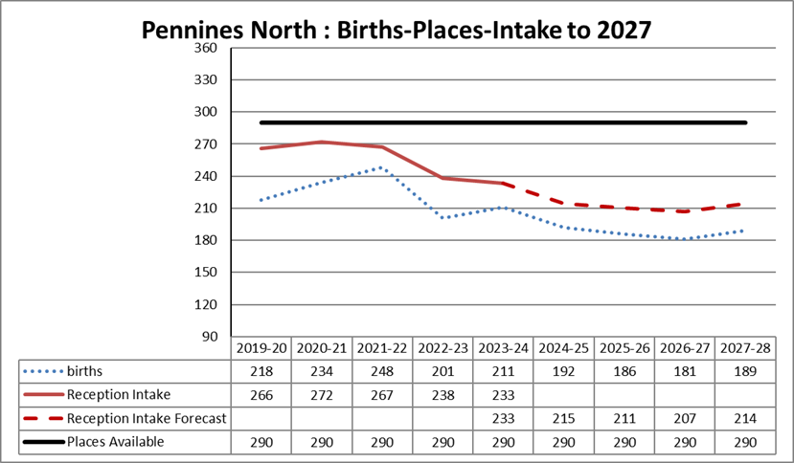

8.3 The forecast for places in Pennines North is shown above and suggests there will be 75 spare places in 2024 and 79 spare places in 2025.

8.4 The School Admissions Code requires a formal consultation on the reduction of Pupil Admission Number to be completed between 1st October and 31st January. The formal determination of the Pupil Admission Number is then required by February 28th in the year preceding the intake year.

8.5 Consultation is ongoing with school leaders and governors and all stakeholders are asked to write in to the formal consultation in the link above.

- Implementation of the Proposals
Rochdale Borough Council as promoter has responsibility for implementing the proposals which must conform to the School Admissions Code.

