

# **Report title: Need for Primary School Places 2024 - 2027**

Report to: Cabinet

Date of meeting: Tuesday, 19 December 2023

Cabinet Portfolio Holder: Cabinet Member for Children’s Services and Education

Report of: Director of Children's Services

Public or private: Open

Key Decision?: Y, is likely to lead to significant expenditure or savings within a service area, or one that is likely to have a significant impact on the life of a community within the Borough.

Published on the Forward Plan: N

## **Report summary**

* 1. The report details the sufficiency in school places and is an annual review of current school places and forecasts up to 4 years ahead. Currently the Council is awaiting the outcome of the Places for Everyone strategy which will indicate some of the possible larger housing developments over the next 10-15 year period. The current forecasts only cover new housing that are in the current five year strategic housing land assessment, but noting that forecasts in some areas could change very quickly if the Places for Everyone strategy is approved.
  2. The report details expenditure needed to manage the schools estate in order to meet the statutory duty of the council to offer a school place to every child living in the borough.

## **Recommendations**

* 1. Approve a formal consultation on the reduction in admission number at Harwood Park Primary School in Heywood for September 2025.
  2. Approve spend to extend St. Johns Thornham Primary school to a capacity of 210 pupils, as detailed in appendix 2.
  3. Approve consultation with schools across Pennine, in both North and South, to reduce Pupil Admissions numbers going forward due to reduction in the underlying local birth rates.

## **Reason for recommendation**

3.1 The council has a statutory duty to provide education and school places to all school aged children living in the borough and consequently has a duty to plan adequately for predicted pupil numbers.

3.2 Under the Education Act 1996, section 14(1) the Local Authority has a duty to secure sufficient school places and is also the strategic commissioner for new school places in its area.

3.3 A local authority shall exercise their functions under this legislation to contribute towards the spiritual, moral, mental and physical development of the community by securing that efficient primary education, and secondary education and, in the case of a local authority in England, further education, are available to meet the needs of the population of their area

## **Alternatives considered**

* 1. Alternative to (2.1) above is to keep the school at its current admission number with the associated teaching capacity which would make the school financially unviable. Schools, including schools maintained by the local authority, are required to set 3 year balanced budgets. Keeping the status quo was rejected as it would be against the best interest of fiscal responsibility.
  2. Alternative to (2.2) above would keep the school at its current capacity and leave the Middleton area without sufficient places within statutory travel to school distance. Keeping the status quo was rejected as put the council’s statutory duty to manage the sufficiency in school places in risk of being breeched.
  3. Alternative to (2.3) would be to not notify schools of the potential they would have smaller intakes in the following years and would have impacts on financial viability of schools as in (4.1) above. Keeping the status quo was rejected as it would be against the best interest of fiscal responsibility.

## **Key information**

* 1. 5.1 Birth rates for the cohort of children starting Primary schools in 2021 peaked at 3,064 births across the borough. Birth rates for the children starting school in 2024 are 2,741, followed by 2,728 in 2025. This is a reduction of 323 and 336 respectively.
  2. Last year consultations were run in three schools to remove 60 places across the borough in Reception classes from September 2024. Revenue funding from the DfE is based on the per pupil count and consequently lower pupil numbers will reduce school’s financial income. Too much spare capacity could impact on school’s ability to budget effectively.
  3. The graph below shows that for the 2022 Reception intake schools had on roll 2,829 pupils at the start of the academic year while the LA had a total of 3,277 school places, meaning in Reception class there were 448 spare school places. Current forecasts indicate similar level of school applications will be seen in 2024 and 2025 intakes.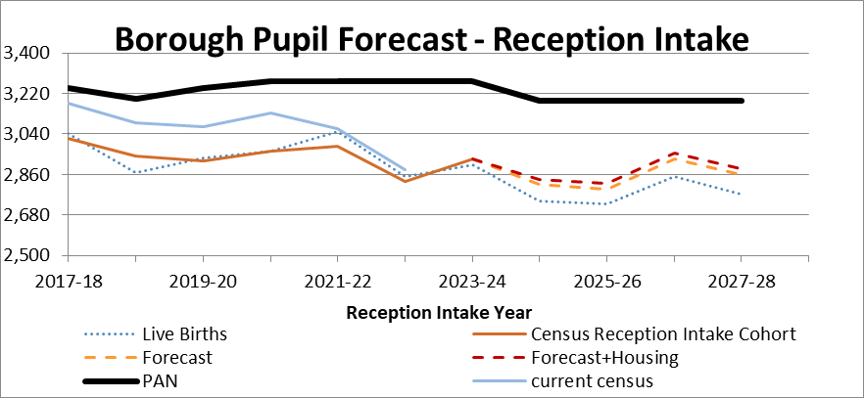
  4. It must be noted that the borough requires a high number of empty places in Reception intake in order to manage in-year applications that are at very high levels. The blue line in the graph above shows the current census for those cohorts and indicates that by Year 3 the borough only has 144 spare places and only 67 spare places in Year 6.
  5. Too many empty places in Reception classes are a considerable financial issue for schools, who are required to maintain balanced budgets and who are required to staff their schools appropriately. Some schools note that they are expected to manage large numbers of pupils arriving after census day when the school funding allocations are set on census numbers.
  6. The borough also has a number of small village schools and rises in staff costs combined with low intakes makes the running of small schools increasingly challenging.
  7. In-Year ‘new’ school applications shown in the graph below indicate that since the low numbers of applications in the first year of covid lockdowns the new applications for school places have grown in each subsequent year. The 2023-24 intake was currently slightly before previous years. 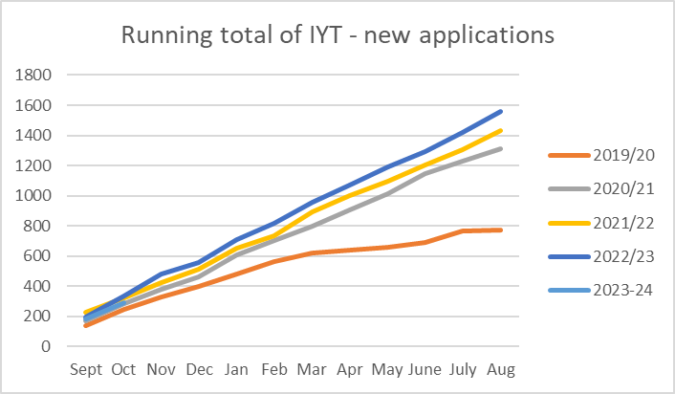
  8. Part of the reason for increasing numbers of new school applications is the rise in numbers of applications particularly in Middleton for Key Stage 2 classes. There is a shortage of good Secondary school places across GM and Middleton had the New Edgar Wood Academy open in its permanent site for 2022 intake along-side the new housing in that area.

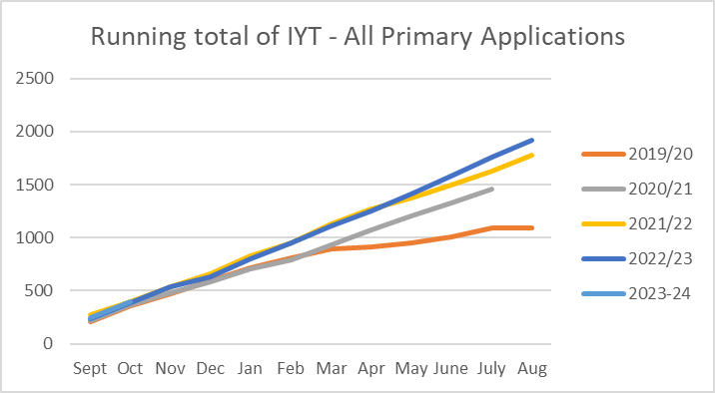

Heywood

* 1. Up to 2019 Heywood saw a 15% increase of children arriving in schools above the local birth rate. Since then arrivals in Reception classes have only matched local birth rates. The area is consequently carrying too many spare places and Harwood Park Primary School has requested to reduce its intake for 2025.

|  |  |  |  |  |
| --- | --- | --- | --- | --- |
|  | **2024-25** | **2025-26** | **2026-27** | **2027-28** |
| **Reception Places Needed** | 101 spare | 92 spare | 91 spare | 86 spare |
| **Plans** | Harwood Park have asked to reduce their intake by 30 from 2025. | | | |
| **Future Issues** |  | New housing is now under-construction in South Heywood and 1000 new homes in the development could mean an increase in places is needed in the future A site for a new school has been provided within the developments. | | |

Middleton

* 1. The area has continued to see large numbers of in-year applications particularly for higher year groups in Primary schools. For the last two years the LA has been asking schools to create more capacity but projects to increase capacity have stalled. Issues associated with post-covid pupil behaviour and high numbers of new starters has meant that schools feel that increasing pupil numbers will put too much strain on teachers and staff.
  2. The Admissions and School Improvement teams within the LA continue to support schools to meet the LA’s statutory duty to place children following parental preference and where appropriate. New families apply for school places particularly in Years 5 and 6 are finding very limited school options. The LA continues to place children successfully within the statutory travel to school distance.
  3. The Director of Children’s Services has requested schools take additional children (over-Pupil Admission Numbers, PANs) in both the summer 2022-23 term and this autumn 2023-24 term in some classes to manage places. There are currently 29 children in over-PAN classes in Year 6; with each school in Middleton having on average 2 additional children.

|  |  |  |  |  |
| --- | --- | --- | --- | --- |
|  | **2024-25** | **2025-26** | **2026-27** | **2027-28** |
| **Reception Places Needed** | 25 spare | 23 spare | 76 places needed | 23 places needed |
| **Plans** | Additional capacity is being sought in upper year groups by asking schools to take additional pupils, and the LA is requesting that a school steps forward to host a new Year 2 class. | | | |
| **Future Issues** | Permanent expansion of school in Middleton is being sought but the LA needs to be mindful of wishes of Head teachers, Governors and School Improvement partners. Permanent expansion of St John’s in Thornham to create 15 additional places for 2024 intake onwards. | | | |

* 1. Since 2018/19 developments within the Langley Lane/ Hollin Lane area and the central Langley “Willow Park” are now almost complete. Analysis of data up to January 2023 shows that within Middleton 960 new homes have been completed with 337 Primary age children arriving in school. While locally new housing continues to be built, the number of new houses in the pipeline is reducing.
  2. Although St John’s in Thornham sits in Castleton Ward the Primary school is within the Middleton School’s collaborative and the school receives a high number of applications from the Middleton area. For this reason the school was approached (along with all the schools in Middleton) to discuss the possibility of increasing its capacity in order to manage the additional place pressures in the Middleton area. In 2021 the school expanded from a capacity of 80 places to a total capacity of 105 places. The school has also worked closely with the council to place in-year applicants and has continued to offer additional places in all year groups when requested. The plans for the ‘Phase 1’ expansion incorporated the ability of the school to be further expanded and this report seeks approval to move forward with the ‘Phase 2’ of the expansion to a 210 capacity and 30 place Reception intake.

Pennines

* 1. For the 2021 Reception intake for north Pennine the underlying birth rate was high, but schools under-recruited with local issues including the rebuilding programme at Littleborough Primary school and the continued lack of Secondary school places having an impact.
  2. Since then birth rates locally have dropped from 248 and will continue to drop until the 2026 intake which has a birth rate of 181. This is a reduction locally of 67 births. Over the last two years local schools have seen too many empty places in Reception classes and some schools have seen a number of key stage 2 children also move out.
  3. Although there is new housing under construction in Littleborough analysis of children from the new housing shows 30% are pre-school and 65% are either higher key stage 2 or Secondary pupils. This mirrors current new housing in Middleton where large numbers of families are moving for Secondary school transition.
  4. The LA needs to look to reduce capacity over in Pennines North over the coming years. With only 7 schools in the Littleborough Lakeside and West Littleborough and Wardle Wards, and only 3 of the schools are two forms of entry, there are not many schools where a reduction of intake would be desirable.
  5. Pennines South always experience is a reduction in applications compared to birth rates. 2024 is expected to be a slightly higher intake year with birth rates indicating a reduction in following years. Consideration should be taken as to whether there is too much capacity in the area.

|  |  |  |  |  |  |
| --- | --- | --- | --- | --- | --- |
|  |  | **2024-25** | **2025-26** | **2026-27** | **2027-28** |
| **Pennines N** | **Extra Reception Places Needed** | 75 spare | 79 spare | 83 spare | 76 spare |
| **Plans** | Despite new housing developments in the area birth rates continue to fall and schools in the area will be consulted on possible reduction of admission numbers. | | | |
| **Future Issues** | Littleborough Primary new build school and any potential new Secondary school, will impact on the desirability of places in this area. There is also potential for more new housing to come forward. | | | |
| **Pennines S** | **Extra Reception Places Needed** | 14 spare | 31 spare | 33 spare | 36 spare |
| **Plans/ Future issues** |  | The area experiences a net out flow of children compared to birth rates. Consideration has to be taken as to whether there is too much capacity in the area. | | |

Rochdale North

* 1. Although the birth rate has dropped by over 100 births per year, from 787 to 680 in the 2025/6 cohort, the area forecast for Reception intake classes stay at approximately 730 until 2027/28. With 789 places available there is expected to be a minimum of 45 places spare.
  2. From 2024 intake Rochdale North pupil admissions are being reduced by a total 30 places by reductions in intakes at Meanwood Primary and St Vincent’s Primary.
  3. Central Rochdale and Healey wards do experience a high rate of in-year applications and sufficient spare places must be retained to manage these applications

|  |  |  |  |  |  |
| --- | --- | --- | --- | --- | --- |
|  |  | **2024-25** | **2025-26** | **2026-27** | **2027-28** |
| **North Rochdale** | **Extra Reception Places Needed** | 47 spare | 75 spare | 45 spare | 64 spare |
| **Plans/ Future Issues** | Plans should continue to be reviewed as too much spare capacity could be an issue. High levels of in-year applications continue to be challenging and need a high level of spare capacity. | | | |

Rochdale South

* 1. Forecasts for pupil intakes in Rochdale South continue to be challenging. Birth rates have zig-zagged with schools under-recruiting in some year groups. The area also sees high levels of in-year applications and consequently there are some key stage 2 year groups where additional classes have needed to be created in previous years.
  2. The current forecast would suggest that recent birth rates are levelling off at around 750 up to 2027/28, and the spare capacity will be approximately 70 spare places per Reception intake.
  3. For 2024 Reception intake Lowerplace Primary school has reduced its intake by 30 places.

|  |  |  |  |  |  |
| --- | --- | --- | --- | --- | --- |
| **C and SW Rochdale** |  | **2024-25** | **2025-26** | **2026-27** | **2027/28** |
| **Extra Reception Places Needed** | 87 spare | 62 spare | 58 spare | 65 spare |
| **Plans/Future Issues** | Additional housing developments currently under construction and associated with Places for Everyone mean that additional capacity is likely to be needed despite current spare capacity | | | |

**Summary**

1. A formal consultation is needed for the reduction in pupil admission number at Harwood Park Primary School to reduce the Pupil Admission Number to 30 from September 2025.
2. Provision of funding for the expansion of St John’s Primary in Thornham to a capacity of 210 to meet a current need for additional places in north Middleton.
3. Consult schools to find extra capacity in Middleton in the year 2 cohort.
4. Consult schools in Pennines North and South to see a reduction in Pupil Admission Number across the region from 2025 onwards.

## **Finance**

6.1 The costs associated with co-ordinating admission arrangements are met from the Dedicated Schools Grant.

6.2 Where applicable, schools offering additional pupil places to meet the LA’s statutory need may also be eligible for additional revenue funding from the Dedicated Schools Grant. The policy and funding available for basic need growth has to be agreed with Schools Forum.

6.3 Schools are funded based on the number of pupils. Whilst it is acknowledged that the LA needs some vacant places for in-year applications, a high number of vacant places can have an adverse effect on school’s revenue funding.

6.4 The costs associated with capital expansions will be met from the Basic Need Capital allocation

## **Legal**

7.1 Under the Education Act 1996, section 14(1) the Local Authority has a duty to secure sufficient school places and is also the strategic commissioner for new school places in its area.

7.2 A local authority shall exercise their functions under this legislation to contribute towards the spiritual, moral, mental and physical development of the community by securing that efficient primary education, and secondary education and, in the case of a local authority in England, further education, are available to meet the needs of the population of their area.

## **Human resource**

8.1 Two scenarios for any additional staff would be funded through school’s revenue (Dedicated School’s Grant) and include DSG funding to academies to undertake to directly employ additional staff, or to maintained schools for posts on council’s standard contracts.

## **Sustainability impact**

* 1. 

## **Other considerations (corporate priorities, risks)**

* 1. EIA
  2. 

Background Papers: none  
Contact: Fay Davies

- fay.davies@rochdale.gov.uk