ROCHDALE BOROUGH COUNCIL
REDUCTION IN PUPIL ADMISSION NUMBER FOR
LOWERPLACE PRIMARY

Notice is given in accordance with the school Admissions Code that Rochdale Borough Council, Children’s Services, Number One Riverside, Smith Street, Rochdale, OL16 1XU, intends to reduce the admissions intake to Lowerplace Primary.

- The name and contact address of the local authority or governing body publishing the
proposals:
Local Authority: Rochdale Borough Council
Address: School Organisation and Development Team, Early Help & Schools, Rochdale Borough Council, Number One Riverside, Smith Street, Rochdale, OL16 1XU

Date of Publication of Proposals for Consultation: 12th December 2022.

- The name, address and category of the school that is proposed to be altered:
Address: Lowerplace Primary, Kingsway, Rochdale ,OL16 4UU

Category of school: Community Primary School.

- The date in which the proposed changes will take effect in terms of both the buildings and additional place provisions:
1st September 2024.

- The place to which representations can be made, and by when:
Any person can make representations on the proposal by using the following link to the council consultation website at: https://consultations.rochdale.gov.uk/research/school-admissions-policy-2024-25 or by sending them by 23rd January 2023 to: Fay Davies, by e-mail at fay.davies@rochdale.gov.uk or in writing to this address: School Admissions, School Organisation & Development Team, Early Help and Schools, Rochdale Borough Council, Number One Riverside, Smith Street, Rochdale, OL16 1XU.

- What is proposed?
The proposal is to permanently reduce Pupil Admission Number at Lowerplace Primary, Rochdale from 90 places to 60 places with effect from 1st September 2024.

- School capacity and places- current pupil numbers and admissions- (distinguishing between compulsory and non-compulsory school age pupils), age range, sex, and special educational needs (distinguishing between boarding and day pupils) for whom provision is currently made:
Lowerplace is a mainstream Primary school and has 503 pupils on roll from Reception to Year 6 based on the May 2022 school census. The current age range of the children is 4-11 and does not include a nursery.
ROCHDALE  MAY 2022  CENSUS | Places 2021 | Rec NOR | Places 2020 | Year 1 NOR | Places 2019 | Year 2 NOR | Places 2018 | Year 3 NOR | Places 2017 | Year 4 NOR | Places 2016 | Year 5 NOR | Places 2015 | Year 6 NOR | Total NOR
Lowerplace | 90 | 70 | 90 | 83 | 90 | 85 | 90 | 82 | 60 | 59 | 60 | 61 | 60 | 63 | 503

The school was expanded to 3 forms of entry (90 PAN) in 2018 because of sustained increasing applications for places. The local authority has a statutory duty to deliver sufficient places for children living in the borough.

- Why do we want to make the change(s)?
Reasons for the reduction of places
7.1 Rochdale Borough Council has a duty to provide sufficient places for children living in the borough. This includes children who move into the borough after the normal start in Reception class and in higher year groups; termed in-year applications. The council has a duty of care to manage school places effectively and schools have a duty to adequately staff their schools.
7.2 The local authority has a duty of care to children in schools to make sure too many empty places are removed in order that the school is adequately financed through its per-pupil funding allocation, and that education is not compromised because of limited finance.
7.3 Birth rates in the area peaked in 2019 at 528 births, and are due to drop to 450 for 2024 and 438 for 2025.
7.5 The central Rochdale area normally sees high in-year applications with approximately an additional 40 children arriving in Key stage 1 and a further 42 children arriving in Key stage 2 years. In the last year, and post-covid the rates of in-flow has more than halved.

Quality of Provision

7.4 The current OfSTED report for Lowerplace Primary was published in June 2019 and the school was judged as ‘Good’ in all categories and ‘Outstanding’ in its Early Years provision. Its intake has a high percentage of disadvantaged pupils.

7.5 The advantages to the school and the children will be:
- More stability in number of pupils
- The school can staff the classrooms to the correct ratios

7.7 The Governing Body of Lowerplace Primary is committed to upholding the standards and ethos of the School. Through the Leadership and Management Team and alongside the Governing Body, the school aspires to provide an 'Outstanding' education to all of the children in its community.

- The need for a reduction in places - a statement and supporting evidence about the need for reducing school places in the area including whether there is sufficient capacity to accommodate additional pupils in the current schools:
8.1 New pupil projections for Rochdale Borough, Township and planning area were published and reported to Cabinet on the 22nd November 2022. Documents were shared with schools on the local authority internal bulletin platform. The consultation information can be found in the link below:

https://consultations.rochdale.gov.uk/research/school-admissions-policy-2024-25

This highlighted the need for reduction in primary school places going forward within the central Rochdale planning area, key factors being:
- Reduction in local birth rates which follow national trends;
- Reduction in take up of in-year places locally;
- Assessment of new housing developments has been considered.

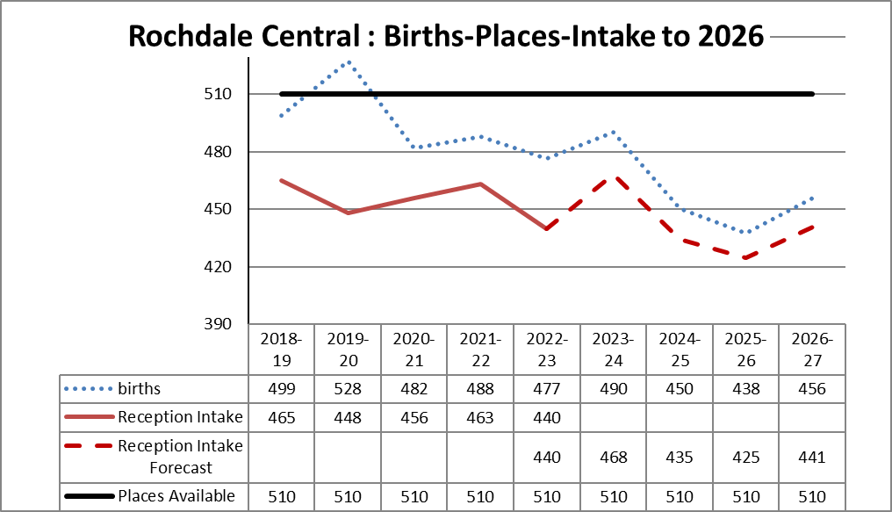

8.2 The forecast for places in central Rochdale is shown above and suggests there will be 75 spare places in 2024 and 85 spare places in 2025.

8.3 The School Admissions Code requires a formal consultation on the reduction of Pupil Admission Number to be completed between 1st October and 31st January. The formal determination of the Pupil Admission Number is then required by February 28th in the year preceding the intake year.

8.4 Pre-Consultation discussions have taken place with school leaders and governors and all stakeholders are asked to write in to the formal consultation in the link above.

- Implementation of the Proposals
Rochdale Borough Council as promoter has responsibility for implementing the proposals which must conform to the School Admissions Code.

