What is an Active Neighbourhood?
An Active Neighbourhood aims to help residents to make short trips on foot, by cycle or by public transport, instead of jumping in their car. Active Neighbourhoods also seek to make our roads a safer place for all users.
This can be achieved through:
- new crossings
- new walking and cycling facilities
- traffic calming
- introduction of measures around schools to improve road safety
- measures to prevent ‘rat running’ in residential streets
- pocket parks
The proposed Milkstone & Deeplish Active Neighbourhoods is part of a Greater Manchester-wide programme to improve the areas where people live, and all 10 local authorities are taking part. Chris Boardman, Greater Manchester’s Transport Commissioner, explains more about what an Active Neighbourhood is in this video and also the option to trial experiential measures before a final decision for an area is made.
https://youtu.be/6WyxdRag5OA (Can we add thumbnail of the video on website page as example below shows??)
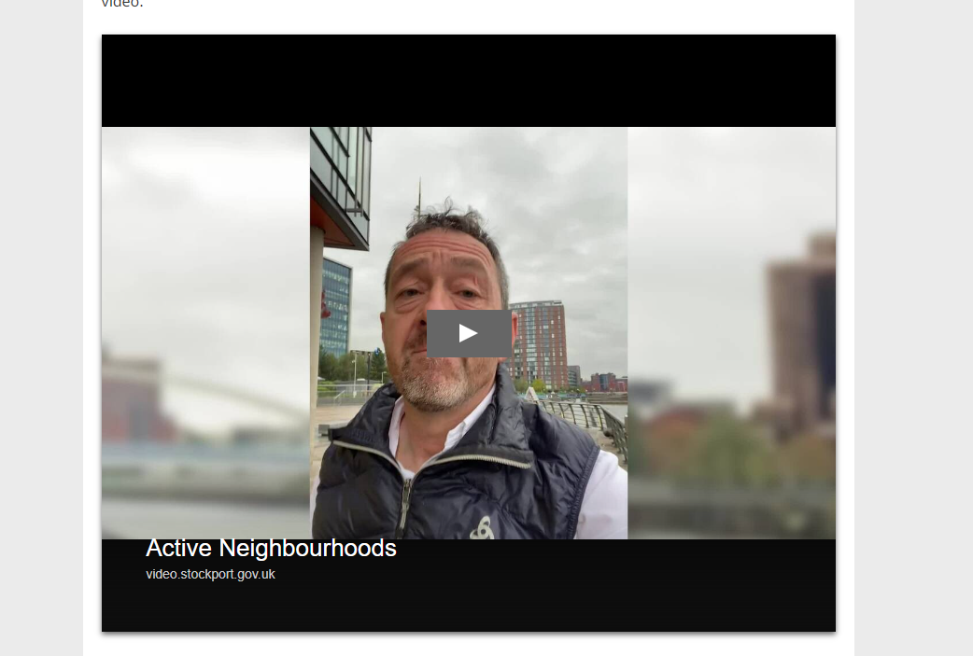
For further information on Active Neighbourhoods and to see examples in other areas of Greater Manchester and to see how people in those areas have found these types of schemes please visit the dedicated Transport for Greater Manchester page below.
https://news.tfgm.com/resources/f/cycling-and-walking/active-neighbourhoods-and-modal-filters

- Can we also have a section which says to find detailed information on the proposed Milkstone & Deeplish Active Neighbourhood please find.

- Draft scheme Proposal Map
- Scheme boundary map
- Leaflet posted to a mix of 4000 residential and business properties
- Also provide a link to the survey page with text to say ‘Please take time to submit the survey provided which will be used to develop the final plan for the area’
Survey link (PAGE NOT LIVE YET) https://tinyurl.com/milkstone-survey

- Also a line to say… ‘On Wednesday 27th July 2022 there will be three public sessions from 4pm-5pm, 5pm-6pm, and 6pm-7pm at Castlemere Community Centre. These consultation sessions will give people a chance to have their say and gain a further understanding of the project before a final scheme is decided upon’.
Link for further info on this event to be included: https://tinyurl.com/milkstone-event

