**Appendices for cabinet report**

**Appendix 1, Section 1**

**Proposed changes to the Rochdale Town Centre Public Spaces Protection Order**

(Changes are marked in red)

|  |  |  |
| --- | --- | --- |
| **Current Prohibition** | **Proposed Prohibition** | **Reason for Variation** |
| **Control of commercial or charity collection or soliciting for money in the street**  No person shall at any time engage in or knowingly cause or permit the collection or soliciting of money for commercial or charitable purposes and whether by way of immediate payment or the seeking of a standing order or direct debit authority unless they are in possession of a written authorisation for face to face fundraising issued by the Council. | No change |  |
| **Consumption of alcohol on street**  No person shall at any time consume alcohol in any public place other than at licensed premises or refuse to hand over an open container containing or purporting to contain alcohol, in their possession. save for in those places identified by section 62 of the Anti-social Behaviour, Crime and Policing Act 2014, when required to do so by an Authorised Officer. | Prohibition to be removed | It is proposed that this restriction will now be included in the proposed borough wide PSPO. |
| **Driving or using a car in an anti-social manner**  No person in charge of a motor vehicle shall allow, cause or permit the :   1. Running of the engine in such a manner that causes or is likely to cause a noise nuisance 2. Playing of music in the motor vehicle at such a level that causes or is likely to cause a nuisance 3. Behaving in a way likely to cause harassment, alarm or distress to any person present at the time of the behaviour including an Authorised Officer 4. Driving the vehicle in a manner that causes or is likely to cause harassment, alarm or distress to any person including an Authorised Officer | No change |  |
| **Obstructing the highway or loitering**  No person shall obstruct, cause or permit an obstruction on the highway, without reasonable or lawful excuse, either by way of a vehicle or any other object, after having been requested to leave or remove the obstruction from the highway by an Authorised Officer | No change |  |
| **Use of skateboards, bicycles and scooters**   1. No person shall at any time use a skateboard in the restricted area shown coloured red on the plan 2. No person shall at any time use a bicycle, skateboard, scooter or similar wheeled conveyance in such a manner that causes or is likely to cause nuisance, alarm or distress | No change |  |
| **Begging**  No person shall at any time beg for money. Persons experiencing destitution, being defined as persons who do not have a fixed abode and/or do not receive an income will be considered to have a reasonable excuse for breaching this prohibition | No change |  |

**Appendix 1, Section 2**

**DRAFT ORDER**

**ROCHDALE BOROUGH COUNCIL**

**Anti-Social Behaviour, Crime and Policing Act 2014, Section 59**

**Rochdale Town Centre Public Spaces Protection**

**(Extension and Variation) Order 2024**

THE Rochdale Borough Council (‘the Council’) in exercise of its powers under Section 60(2) and 61(1)(b) of the Anti-social Behaviour, Crime and Policing Act 2014 (‘the Act’) and of all other enabling powers and being satisfied that the requirements of the Act have been met hereby make the following Order:-

1. The Rochdale Town Centre Public Spaces Protection Order 2018 (‘the 2018 Order’) which took effect on 23rd July 2018 and was extended for a further period of three years from 22nd July 2021, is further extended for a period of 3 years from 23rd July 2024 to 22nd July 2027.
2. The 2018 Order be varied as shown in Schedule 1 below.
3. The Rochdale Borough Council Town Centre Public Spaces Protection (Extension and Variation) Order 2024 (‘the 2024 Order’) applies to the public spaces described in Schedule 2 below and edged in blue and coloured red on the plan annexed to this Order (‘the Restricted Area’).
4. The effect of the 2024 Order will be to extend the 2018 Order to 22nd July 2027and to vary the 2018 Order in accordance with Schedule 1.
5. This Order shall be cited as the Rochdale Town Centre Public Spaces Protection (Extension and Variation) Order 2024. The Order shall take effect on 23rd July 2024and will be in force for 3 years, subject to any further variation or extension of the Order.

**Offences under this Public Spaces Protection Order:**

1. A person who is guilty of an offence shall on summary conviction be liable to a fine not exceeding level 3 on the standard scale.
2. A Fixed Penalty Notice of £100.00 will be issued to offenders (reduced to £60.00 if paid within 14 days) which would discharge any liability to conviction for an offence under Section 67(1) of the Act.
3. This order may be cited as 'The Public Spaces Protection Order (Borough wide 2024)’ and shall come into force on (date of commencement) and remain in force for a period of three years.

**SCHEDULE 1**

1. The following restrictions contained in the 2018 Order will now read as follows :-
2. Control of commercial or charity collection or solicitor for money in the street

No person shall at any time engage in or knowingly cause or permit the collection or soliciting of money for commercial or charitable purposes and whether by way of immediate payment or the seeking of a standing order or direct debit authority unless they are in possession of a written authorisation for face to face fundraising issued by the Council.

(b) Obstructing the highway or loitering

No person shall obstruct, cause or permit an obstruction on the highway, without reasonable or lawful excuse, either by way of a vehicle or any other object, after having been requested to leave or remove the obstruction from the highway by an Authorised Officer.

(c) Begging

No person shall make any verbal, non-verbal or written request for money, donations or goods, including the placing of hats, clothing or container so as to cause or is likely to cause intimidation, harassment, alarm or distress to any person

1. Restriction, numbered 3 in the 2018 Order, Consumption of alcohol on street is removed in its entirety
2. Restriction, numbered 6 in the 2018 Order, Anti-social parking is removed in its entirety
3. All other restrictions in the 2018 Order to remain the same.

**SCHEDULE 2**

**RESTRICTED AREA**

All that land in Rochdale Town Centre comprising 89.29 hectares and which for the purpose of identification is shown edged blue together with the land coloured red on the attached plan.

Dated this day of July 2024

**THE COMMON SEAL** of **ROCHDALE** )

**BOROUGH COUNCIL** was )

hereunto affixed in the presence of )

Authorised Signatory

**Appendix 1, Section 3**

**Current town centre order**

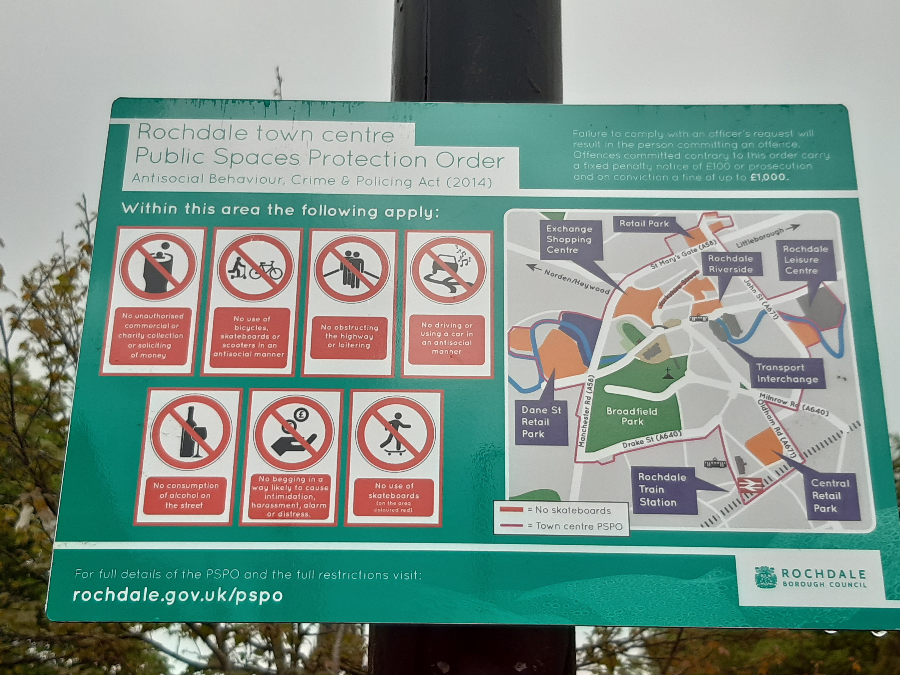

**Appendix 1, Section 4**

**GMP incidents recorded in relation to offences under the current town centre PSPO**

|  |  |
| --- | --- |
| **Incident/report** | **Number of incidents**  **July 2021 – March 2024** |
| Begging | 65 |
| Loitering | 3 |
| Wheeled conveyance  (including vehicles/bikes/scooters/skateboards acting in an anti-social manner) | 27 |
| Unauthorised commercial/charity collection | 0 |
| **Total** | **95** |

**Rochdale Borough Council recorded incidents in relation to offences under the current town centre PSPO**

|  |  |
| --- | --- |
| **Incident/report** | **Number of incidents**  **July 2021 – March 2024** |
| Begging | 76 |
| Loitering | 4 |
| Wheeled conveyance  (including vehicles/bikes/scooters/skateboards acting in an anti-social manner) | 0 |
| Unauthorised commercial/charity collection | 0 |
| **Total** | **80** |

**Appendix 1, Section 5**

**RBC enforcement figures**

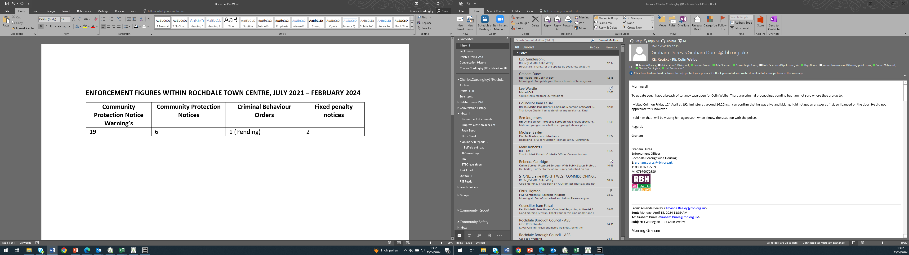

**Appendix 1, Section 6**

**Community Safety enforcement process**



**Appendix 1, Section 7**

**Town centre partner agencies**

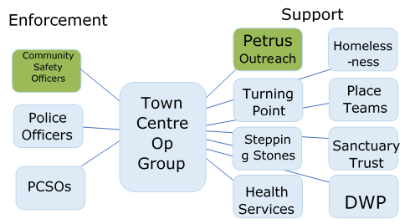

**Appendix 2**

**CONSULTATION QUESTIONS**

**Collection of monies for commercial or charitable purposes**

**1** Do you think people asking for and/or collecting money in the street for charitable or commercial collections is a problem within the public areas shown on the PSPO restricted area map?

*Please select only one item*

* Yes
* No
* Don't know

**2** Has asking for money and/or collecting money for commercial or charitable collections had a negative impact on you enjoying public areas within the PSPO restricted area map?

*Please select only one item*

* Yes
* No
* Don't know

If yes, please give details of how this has affected you

**3** Do you agree we should stop people from asking for money and/or collecting money for commercial or charitable collections in the area shown in the PSPO restricted area map?

*Please select only one item*

* Yes
* No
* Don't know

**4** If you have any additional comments about this subject please let us know:

Please comment below:

**Begging**

**5** Do you consider begging to be a problem in the public areas shown on the PSPO restricted area map?

*Please select only one item*

* Yes
* No
* Don't know

**6** Has this type of behaviour (begging) had a negative impact on you enjoying the public areas shown on the PSPO restricted area map?

*Please select only one item*

* Yes
* No
* Don't know

If yes, please give details of how this has affected you

**7** Do you think it is necessary to stop begging in public areas as shown on the PSPO restricted area map?

*Please select only one item*

* Yes
* No
* Don't know

**8** If you have any additional comments about this subject please let us know

Please comment below:

**Skateboarding and the usage of other wheeled conveyances**

**9** Do you feel that skateboarding is a problem in the area highlighted in red (Yorkshire Street) within the PSPO restricted area map?

*Please select only one item*

* Yes
* No
* Don't know

**10** Do you feel that the use of bicycles, skateboards, scooters or similar wheeled transport used to annoy, scare or upset people in the public areas shown in the PSPO restricted area map is a problem?

*Please select only one item*

* Yes
* No
* Don't know

**11** Has this type of behaviour had a negative impact on your enjoyment of the public areas shown in the PSPO restricted area map?

*Please select only one item*

* Yes
* No
* Don't know

If yes, please give details of how this has affected you

**12** Do you agree we should stop people from using a skateboard in the in the public areas shown in red on the PSPO restricted area map?

*Please select only one item*

* Yes
* No
* Don't know

**13** Do you think we should stop people from using a bicycle, skateboard, scooter or similar wheeled transport in such a manner that causes or is likely to cause nuisance, alarm or distress within the PSPO restricted area map?

*Please select only one item*

* Yes
* No
* Don't know

**14** Please provide any additional comments you want to make about the proposal to stop people using a skateboard in the in area highlighted red shown in the PSPO restricted area map

Please comment below:

**15** Please provide any additional comments you want to make about the proposal to stop people from using a bicycle, skateboard, scooter or similar wheeled conveyance in such a manner that causes or is likely to cause nuisance, alarm or distress.

Please comment below:

**Motor Vehicle Usage**

**16** Do you think people driving or using a vehicle in an antisocial manner in the public areas in the PSPO restricted area map is a problem?

*Please select only one item*

* Yes
* No
* Don't know

**17** Has driving or using a vehicle in an antisocial manner had a negative impact on you enjoying the public areas shown on the PSPO restricted area map?

*Please select only one item*

* Yes
* No
* Don't know

**18** Do you agree we should stop people from driving or using a vehicle in an antisocial manner in the area shown in the PSPO restricted area map?

*Please select only one item*

* Yes
* No
* Don't know

**19** If you have any additional comments about this subject please let us know

Please comment below:

**Blocking roads or pavements**

**20** Do you think people blocking the road or pavement in the public areas in the PSPO restricted area map is a problem?

*Please select only one item*

* Yes
* No
* Don't know

**21** Has blocking the road or pavement had a negative impact on you enjoying the public areas shown on the PSPO restricted area map?

*Please select only one item*

* Yes
* No
* Don’t Know

**22** Do you agree we should stop people from blocking the road or pavement in the area shown in the PSPO restricted area map?

*Please select only one item*

* Yes
* No
* Don't know

**23** If you have any additional comments about this subject please let us know

Please comment below: