PENNINES TOWNSHIP BIRTH DATA- DISTRIBUTION MAPS

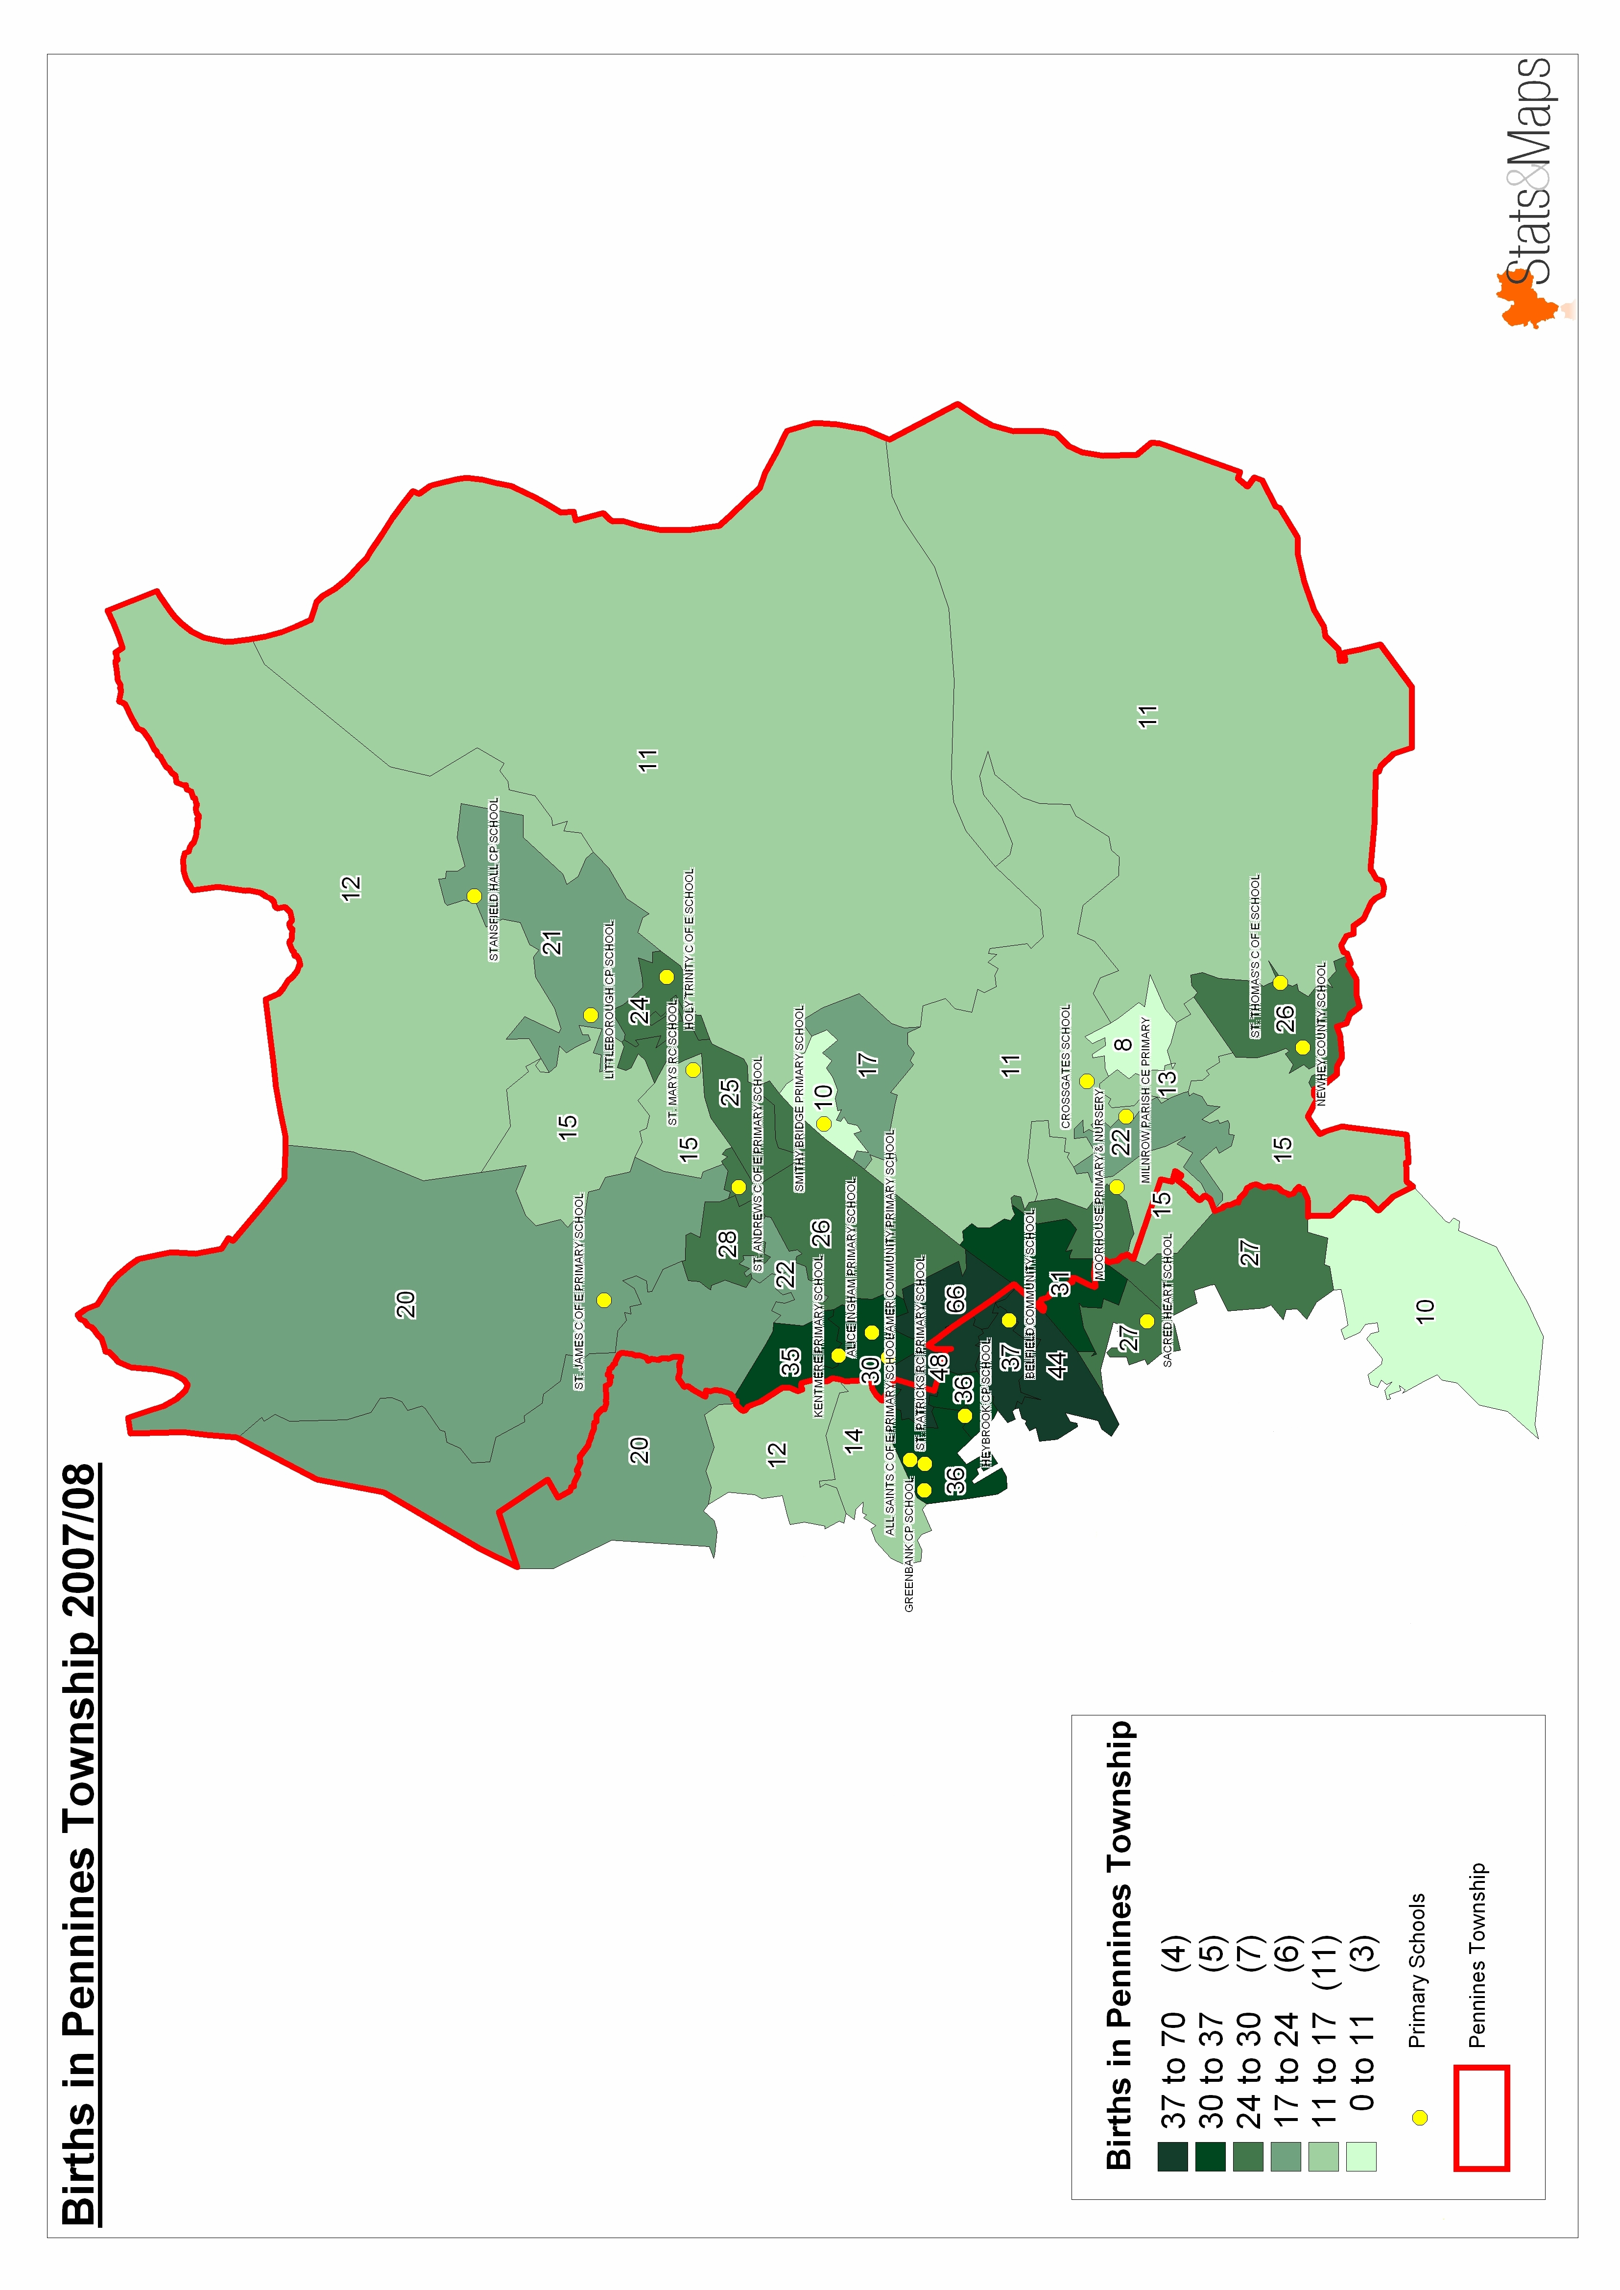
Births 200708 for Admission Sept 2012
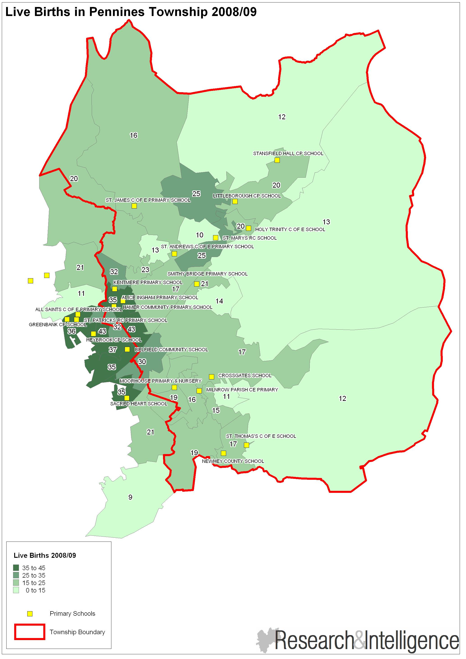
Births 2008-09 for admission September 2013
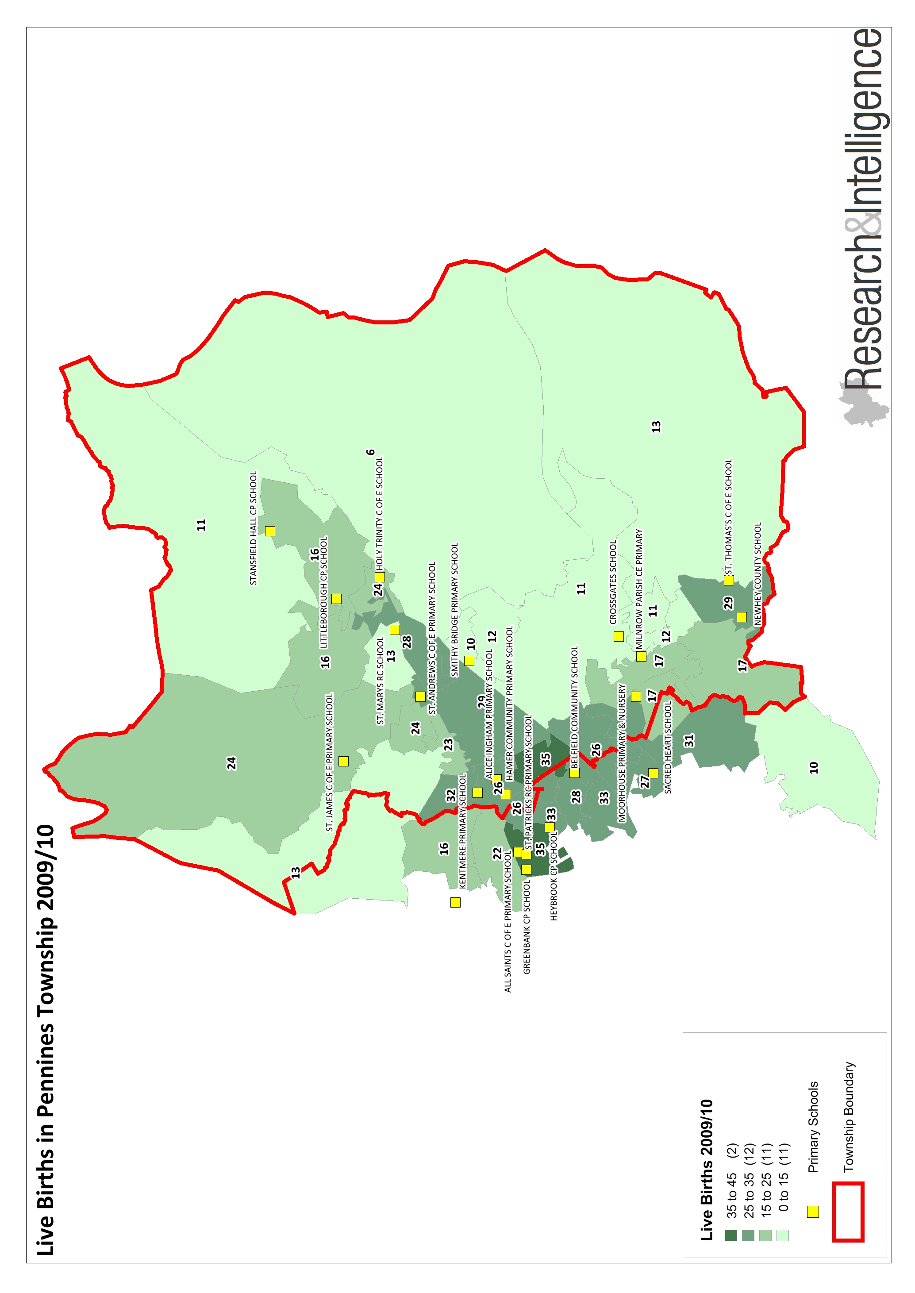
Births 2009-10 for admission Sept 2014
BIRTH DATA BY WARD PENNINES TOWNSHIP

Pennines | Sep-13 | Sep-14 | Sep-15
Littleborough Lakeside | 116 | 100 | 99
Milnrow and Newhey | 108 | 115 | 130
Smallbridge and Firgrove | 204 | 198 | 207
Wardle and West Littleborough | 110 | 114 | 122
 | 538 | 527 | 558

