CHILDREN, SCHOOLS & FAMILIES
SUPPORT FOR LEARNING SERVICE

Sandra Bowness, Service Director

E-mail: Dawn.Jennings@rochdale.gov.uk
Date: 1st May 2012

Former Balderstone Technology College site
Queen Victoria St, Rochdale, OL11 2HJ

Land disposal - consultation

This letter is to tell you that the Local Education Authority plans to dispose of the former Balderstone Technology College site and is giving you the chance to comment on this proposal.

In August 2013 this site will be vacant. Kingsway Park High School currently occupies the site whilst building work takes place at their Turf Hill Road site. The former Balderstone school site is then surplus to educational requirements. The Authority therefore proposes to dispose of part of the site for redevelopment, but needs to ask permission from the Government to do this.

Between 2005 and 2011 local residents worked closely with the Council to agree objectives for a masterplan for the future development of the Balderstone & Kirkholt neighbourhood. These objectives formed the basis for the Vision for Kirkholt Masterplans - “Ideas for Change” (2007) and “Key Sites” (2011). The Council carried out very extensive public consultations during master planning which demonstrated residents’ strong support for the development of future uses on and around the school site in the following ways –
- Building new homes for the neighbourhood.
- Improvement of recreational green spaces, including playing fields.
- Retention, wherever possible, of existing sports facilities (including the sports wing building attached to the school).
The Council now intends to consider the options for re-development of the school site in line with the above objectives.

The financial proceeds from the development of this site will be re-invested in secondary school buildings and their external sports provisions through the ongoing ‘Building Schools for the Future’ programme.

The plan on the back of this letter shows the area within the red line which will be disposed of as a school site and the green area (the playing fields) which will be kept.

Before the Authority asks for permission to dispose of the land, you can tell us what you think. Please forward any comments, concerns or letters of support to the address below by 13th July 2012 and these will be included in the process. This consultation is only concerning the disposal of the educational site and not any of the future details of the Kirkholt Masterplan.

Please send your comments or views to Dawn Jennings, using the postal address below, or via dawn.jennings@rochdale.gov.uk or through our website on the consultations page (http://consultations.rochdale.gov.uk).

Should you require this information in an alternative language or format please call this number 01706 925091.

However if you have any questions regarding the Kirkholt Redevelopment Masterplan, please email vivienne.hall@rochdale.gov.uk

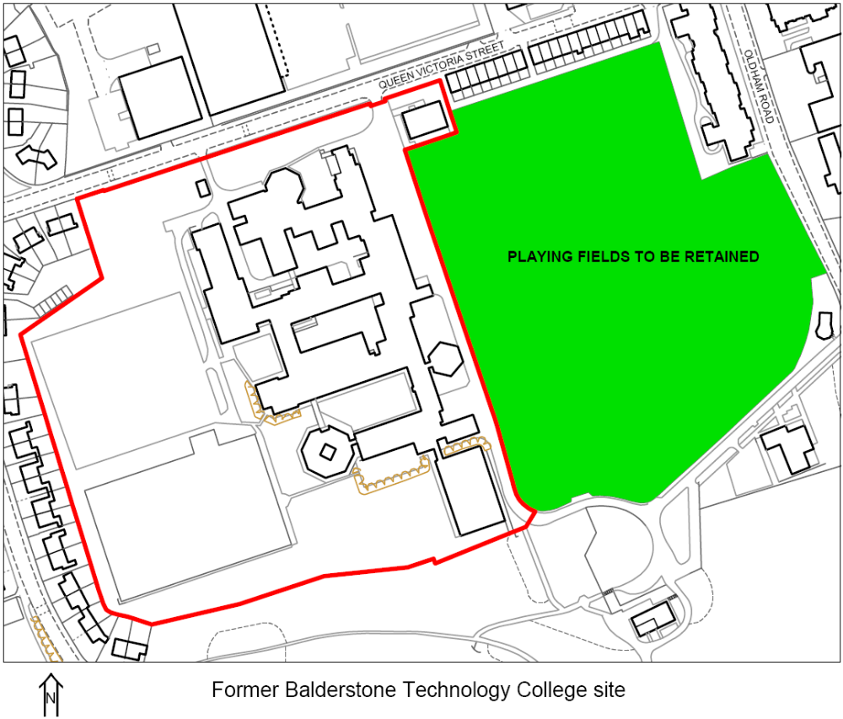
Should you require this information in an alternative language or format please call this number 01706 925008.

