Stage 1: Initial Screening

Directorate: Economy & Place

Service: Environmental Management

Officer completing EIA: Ian Trickett

Other officers involved in completing EIA: None

Date of Assessment: 10/1/25

Name of policy to be assessed: Bowling Green’s / Public Health Funding Withdrawal

Is this a new or revised policy?

New ☒ Revised ☐

What is the purpose of the policy?
Respond to loss of Public Health funding to EM Service budgets for the maintenance of bowling greens

Are there any other objectives?
To find a mechanism to replace this funding to ensure services to the public are not closed

Who is likely to benefit from the policy (key stakeholders)?
People who want to play bowls, predominantly older people.

Is the policy relevant to equality?

Yes ☒ No ☐

(Answer yes if you think that the policy has equality considerations for example it has the potential to affect groups in different ways. If you have answered yes, proceed to question1. If you answered no, move to the sign off section as no further assessment is required)

What information do you have to inform this initial assessment?

Cabinet report

What is the potential impact that the policy could have with regard to the protected characteristics?

(Identify whether the policy has the potential to impact in a positive or negative way or not at all. For negative impacts use the impact table to calculate a score based on the likelihood that an impact will occur and what the actual impact might be then determine whether it is a High priority (H), Medium priority (M) or Low priority (L))

 |  | Positive Impact | Negative Impact | Impact Score (1-25) |  | Impact priority  (H/M/L) | Neutral  Impact
Age |  | ☐ | ☒ | 5 |  | L | ☐
Disability |  | ☐ | ☐ |  |  |  | ☒
Gender Reassignment |  | ☐ | ☐ |  |  |  | ☒
Marriage or civil partnership |  | ☐ | ☐ |  |  |  | ☒
Pregnancy or maternity |  | ☐ | ☐ |  |  |  | ☒
Race |  | ☐ | ☐ |  |  |  | ☒
Religion or belief |  | ☐ | ☐ |  |  |  | ☒
Sex |  | ☐ | ☐ |  |  |  | ☒
Sexual orientation |  | ☐ | ☐ |  |  |  | ☒
Serving / ex serving members of the armed forces |  | ☐ | ☐ |  |  |  | ☒
Carers |  | ☐ | ☐ |  |  |  | ☒
3. Do any of your negative impact scores identify as high priority on the impact table?

Yes ☐ No ☒

If you identify a negative impact as being HIGH PRIORITY you must complete a full EIA (stage 2 onwards)

4. How will you minimise/remove any negative impact that identifies as medium or low?

Although the likelihood of impact is high (5) the impact is low (1) because:
- the number of people involved is low (previous research with bowls clubs indicates c 1,000 members) compared to total population elderly people
- bowls is only one of multiple opportunities in the Borough for elderly people to exercise / have social contacts
- the impact of there being now bowls facilities is not as critical as loss of key services e.g. health care
- the purpose of this cabinet report is to find an alternative to closure through direct or in kind contributions from bowls clubs to cover the cost of the loss of public health funding
The report identifies ways clubs can contribute costs and even in the case of full direct payments, given number of bowls club members this would equate to less than £27 per member or around 50p a week. Also, options are available to bowls clubs for in kind contributions to the maintenance of greens that would reduce the direct payments required.

5. Is a full EIA required?

Yes ☐ No ☒

Lead Officer Signature: | Ian Trickett  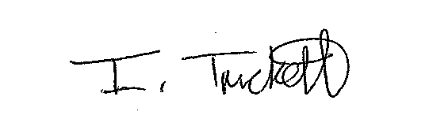 |  |  |  | Date: 10/1/25
Approver Signature | Martin Taylor  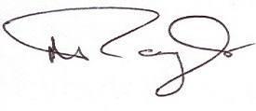 |  |  |  | Date: 10/1/25

