**2021/22 Adult Social Care Fee Rate Consultation – Additional Information Requests/ Queries**

**Home care & Outreach Financial Modelling**. Several requests were made at the consultation meetings to provide more information on the financial modelling in relation to the home care and outreach proposed rates. The table and narrative below shows some detail for people to take into account.

**Home Care/ Outreach**

**Q1 - Breakdown of the hourly rate requested**

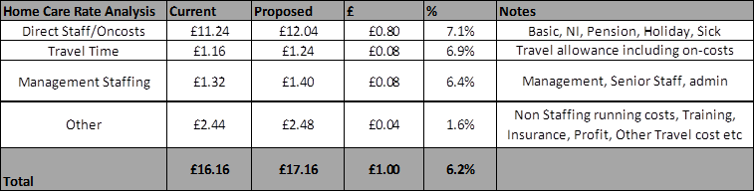

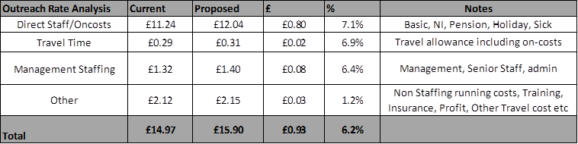

Pay Rate Details/ assumptions

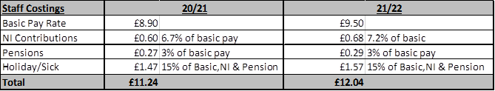

NI Calculation is based on:-

|  |  |  |
| --- | --- | --- |
| **NI Calculation** | **20/21** | **21/22** |
| Hourly rate | £8.90 | £9.50 |
| Weekly Salary | £329.30 | £351.50 |
| NI Threshold 20/21 | £169.01 | £169.01 |
| Pay subject to NI | **£160.29** | **£182.49** |
| NI at 13.8% | £22.12 | £25.18 |
| **NI as % of Basic Pay** | **6.7%** | **7.2%** |

The rates don’t include an assumed increase in the NI threshold, which would reduce the NI contribution rate.

**Q2 – How have management costs been determined?**

The management cost has been determined based on the contribution required per hour for an average sized home care provider to fund their management team. The uplift in management cost will allow providers to maintain a differential in pay rates, although at a reduced % difference.

The rate breakdown for Supported Living is below:-

**Supported Living**

**Q1 - Breakdown of rate requested**

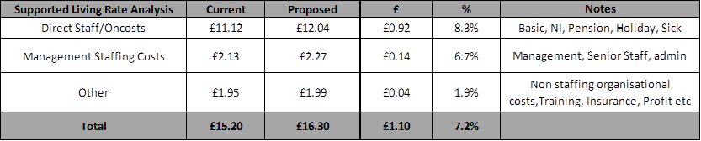

Supported Living On costs are shown below:-

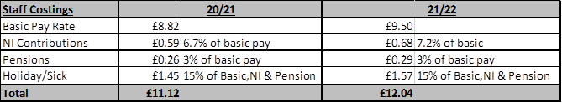

NI rate calculations are shown below:-

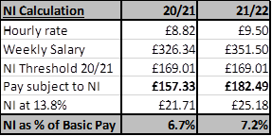

The rates don’t include an assumed increase in the NI threshold, which would reduce the NI contribution rate.

**Q2 – Is the complex rate being removed?**

No, the complex rate will remain £1 above the standard rate