Different things to do in the day
What do you think?

Adult Social Care
Day Services Review
2020
Stage 1 –
Gathering feedback

Introduction

 |  | Rochdale Council is exploring different ways of working for day care services
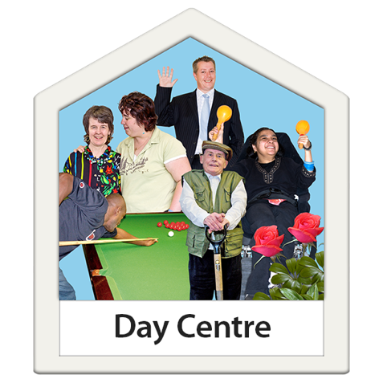 |  | Day care services are different activities for people who need support during the day.
 |  | Many of these services had to close during the Covid-19 lock down. Now they are open they can’t safely fit in as many people
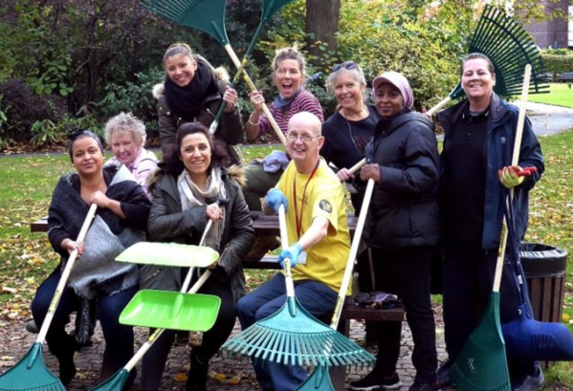 |  | Rochdale Council wants to make sure everyone who needs support can access it even if we have another Covid lock-down. This might include activities in the local community
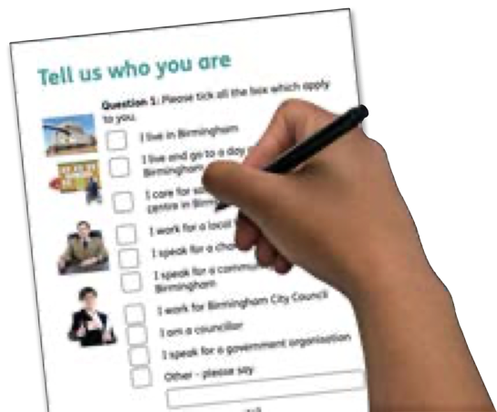 |  | We want to know what you think?  Please tell us about your experiences by answering the questions in this questionnaire
 |  | Your views will help us when we make the final decision.
 |  | We need to have your feedback by the end of October 2020

Tell us who you are?
Question 1: Please tick all the boxes which apply to you.

Age
18-34 Yrs
35-49 Yrs
50-64 Yrs
65-79 Yrs
80+ Yrs
I’d rather not say

Gender
Male
Female
Other
I’d rather not say

What is your religion?
No religion
Christian
Buddhist
Hindu
Jewish
Muslim
Sikh
Any other religion

Which Day Centre do you attend?
Provider | Centre | Please tick
Gateway Leisure | ALPS
Gateway Leisure | EDI
Gateway Leisure | Libra
Gateway Leisure | Muskaan
Gateway Leisure | New Visions
Gateway Leisure | Other Gateway Service
Possabilities | Cherwell Annexe
Possabilities | Pine Street
Possabilities | Victoria House
Possabilities | Witley Road
Possabilities | Other PossAbilities Service
Pure Innovations | Jonathan Burns Centre
Pure Innovations | Other Pure Innovations Service
OTHER DAY CENTRE

What do you like?

Q3: What activities do you enjoy doing at your day centre?
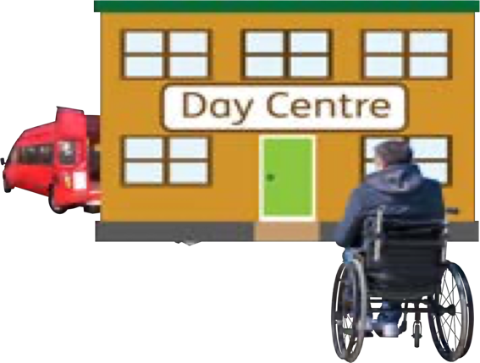 | Visiting day centre
 | Support from staff in the day centre
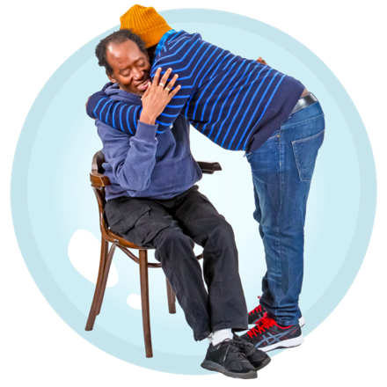 | Meeting friends/family
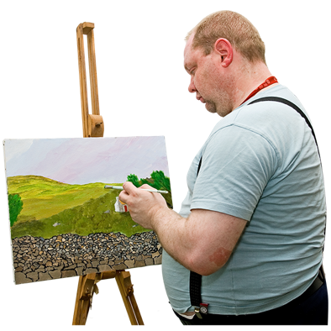 | Art: Colouring, drawing, painting
 | Listening to music
 | Keep fit sessions
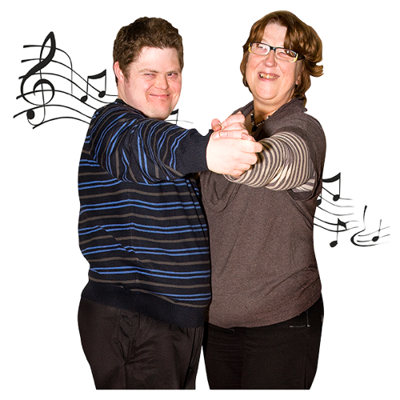 | Dance classes, dancing
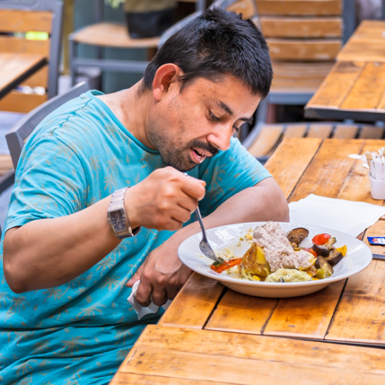 | Health and wellbeing classes (e.g. healthy eating)
 | Cookery sessions
Games (e.g.
board games, cards, bingo)
 | Feeling safe
 | Cultural /religious celebrations

Q4: Are there other things you enjoy about the day centre? Tell us what they are?

Q5: What activities do you enjoy doing away from the Day Centre?
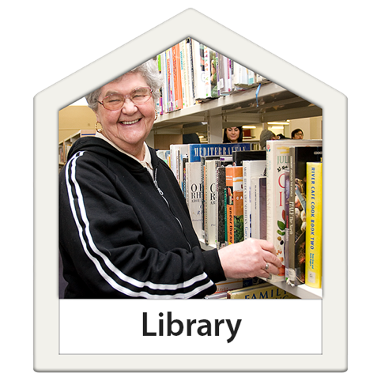 | Day trips (museums, cinema, picnics, libraries, etc.)
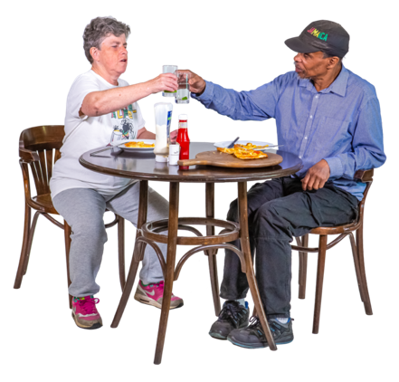 | Going to restaurants, pubs, cafes
 | Shopping
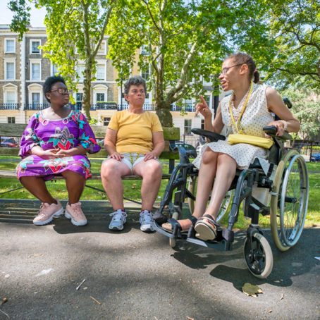 | Meeting new people
 | Volunteering to help out – e.g. gardening
 | Getting help with finding a job
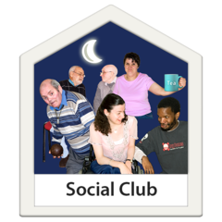 | Going to social clubs or gigs
 | Swimming
 | Watching TV, video games, internet browsing
 | Social Media
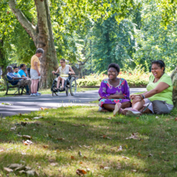 | Parks, gardens, and nature
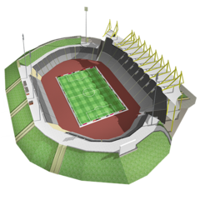 | Watching sport (football, rugby, cricket, etc)
 | Gym

Q6: Are there other activities you enjoy away from the day centre? Tell us what they are?

What don’t you like?
 | Q7: Is there anything about the activities at your day centre that you don’t like?
For example: |  |  | TICK:
- Not enough staff to help?
- You want to come more often but can’t?
- Opening hours not flexible?
- Transport difficulties?
- Not enough choice or control over activities?
- You get bored with the same activities?
- Nothing! You like everything about it

Q8: Tell us about any other things you don’t like about attending your day centre?

 |  | Q9: Is there anything about doing activities away from your day centre that you don’t like?
For example: |  |  | TICK:
- Transport difficulties?
- Access to toilets and changing facilities?
- Cost of activities?
- Not knowing what services are available?
- Local activities are not accessible and inclusive?
- There’s no one there who helps you?
- Communication barriers with the public
- Using public transport
- Feeling isolated
- Feeling misunderstood
- Not feeling safe
- You get bored staying at home

Q10: Any other things you don’t like about activities away from the day centre?:

What needs to change because of Covid-19?
 | Q11: If you can’t attend the day centre as much as you used to because of Covid-19, what could we change to give you different support?
For example: |  | TICK:
- More flexible opening hours at my day centre?
- More opportunities to meet friends and family?
- Better transport links?
- Better public facilities including accessible toilets and changing rooms?
- More access to technology and training so I can do more online?
- More local activities that are accessible and inclusive?
- More volunteering opportunities to help other people?
- More access to employment opportunities so I can try to find a job?
- Better public awareness of disabilities

Q12: Any other things you think we should try to change?

